|  |  |  |  |  |  |
| --- | --- | --- | --- | --- | --- |
| Date | 9-Dec-22 | | | Tester Name | Janette Paus |
| Environment | Penfax - Test 2 | | | Login used |  |
| Operating System | Windows | Version: 21H2 | Update Number: | | |
| Software Used | Select Software | Version: 107.0.1418.56 | Update Number: | | |
| Select Software | Version: | Update Number: | | |
| Application Release version | R22.4.1 | | | | |
| Test Case Title | E20.11 | | | | |
| Test Type | Regression | | | | |
| Test Scenario | Replace a Payment – EFT & Cheque  Scenario 1 – VPB Lump Sum via EFT  Scenario 2 – PEPP Replacement Cheque to FI (no tax) | | | | |
| Expected Results | After a payment is processed to a member & FI, replace the cheque or EFT to re-issue the payment in benefit recipient, will process overnight.  To Confirm results – check that the payment was re-issued and that there is a new paid by payment ID. Check that there is no breakage attributed to the transaction.  Check that T4 only shows the initial payment (and doesn’t double with withdrawal amount) | | | | |
| Pass/Fail | Pass | | | JIRA# |  |

To find a member (lots of ways), but I went to batch processes and searched the PEPP daily letter report

Selected the Date August 23rd (to ensure I’m not interfering with any tester processing, this was before the region was refreshed).

Scroll down to member withdrawal letter, choose from member numbers

**Scenario 1- VPB Lump Sum via EFT:**

SID 247391

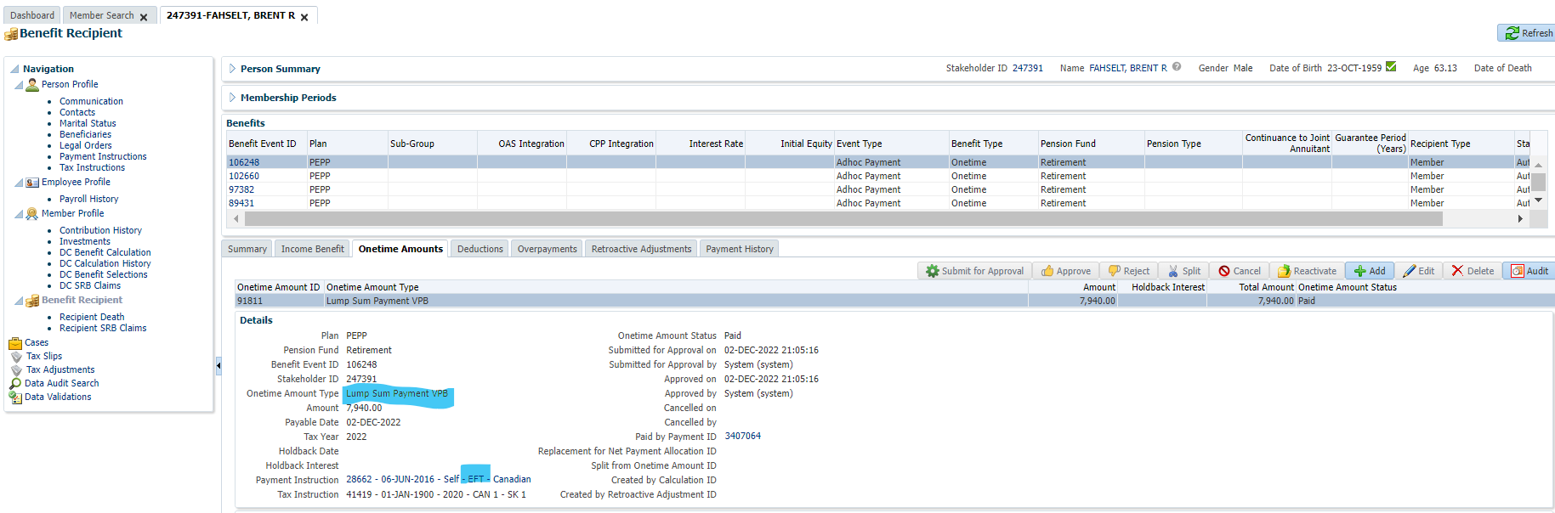

Go to benefit recipient and click on one time amount

Click on the paid by payment ID and click on the net pay allocation tab:

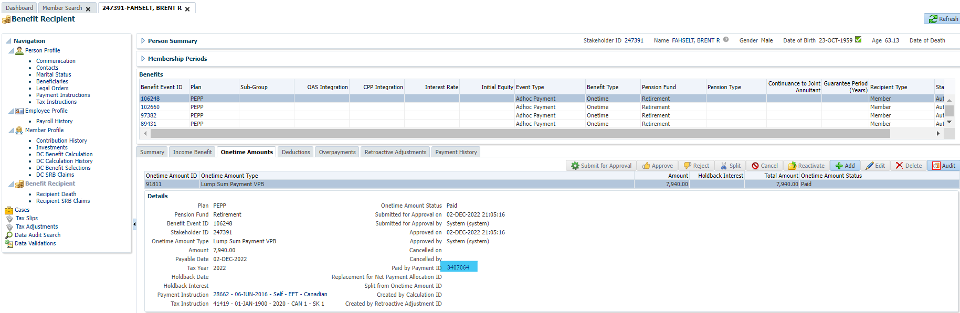

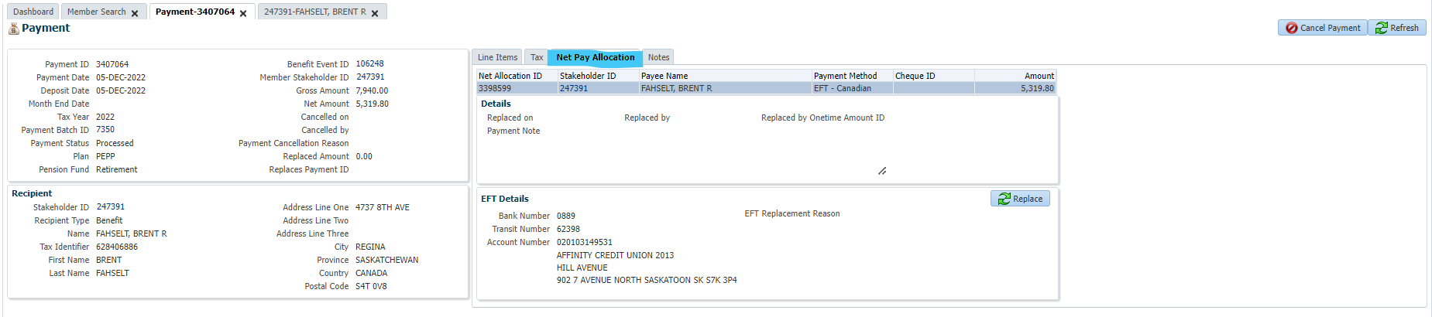

Click on the “replace button” & the replacement reason:

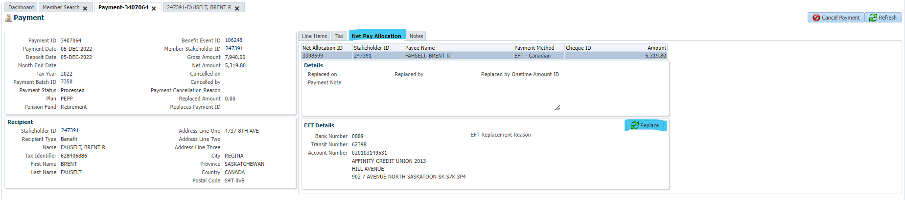

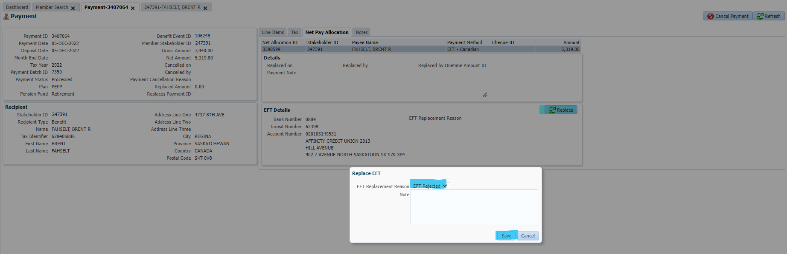

Penfax automatically creates a replacement payment for the amount payable to the member (eg the 8k minus the taxes and deductions).

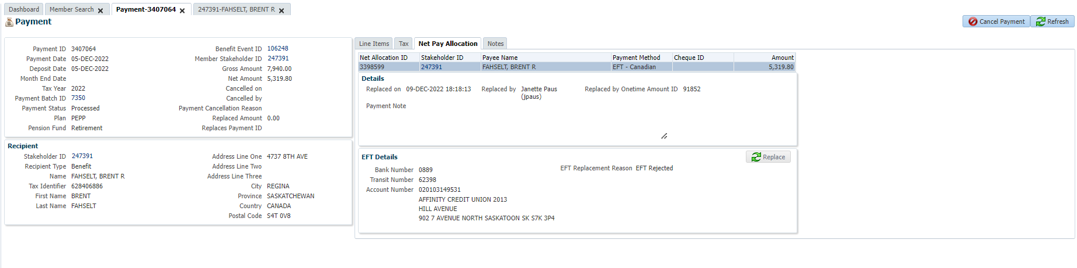

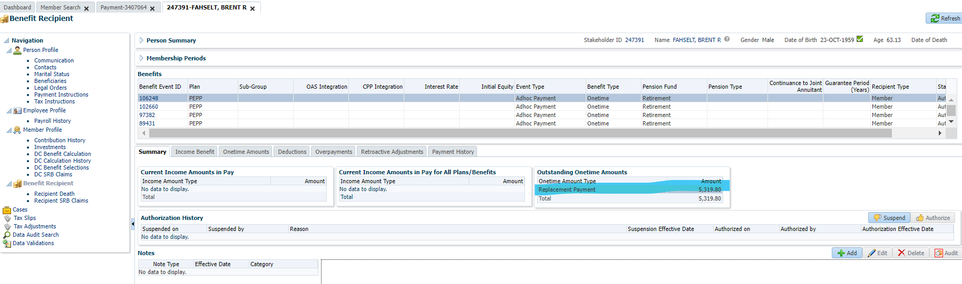

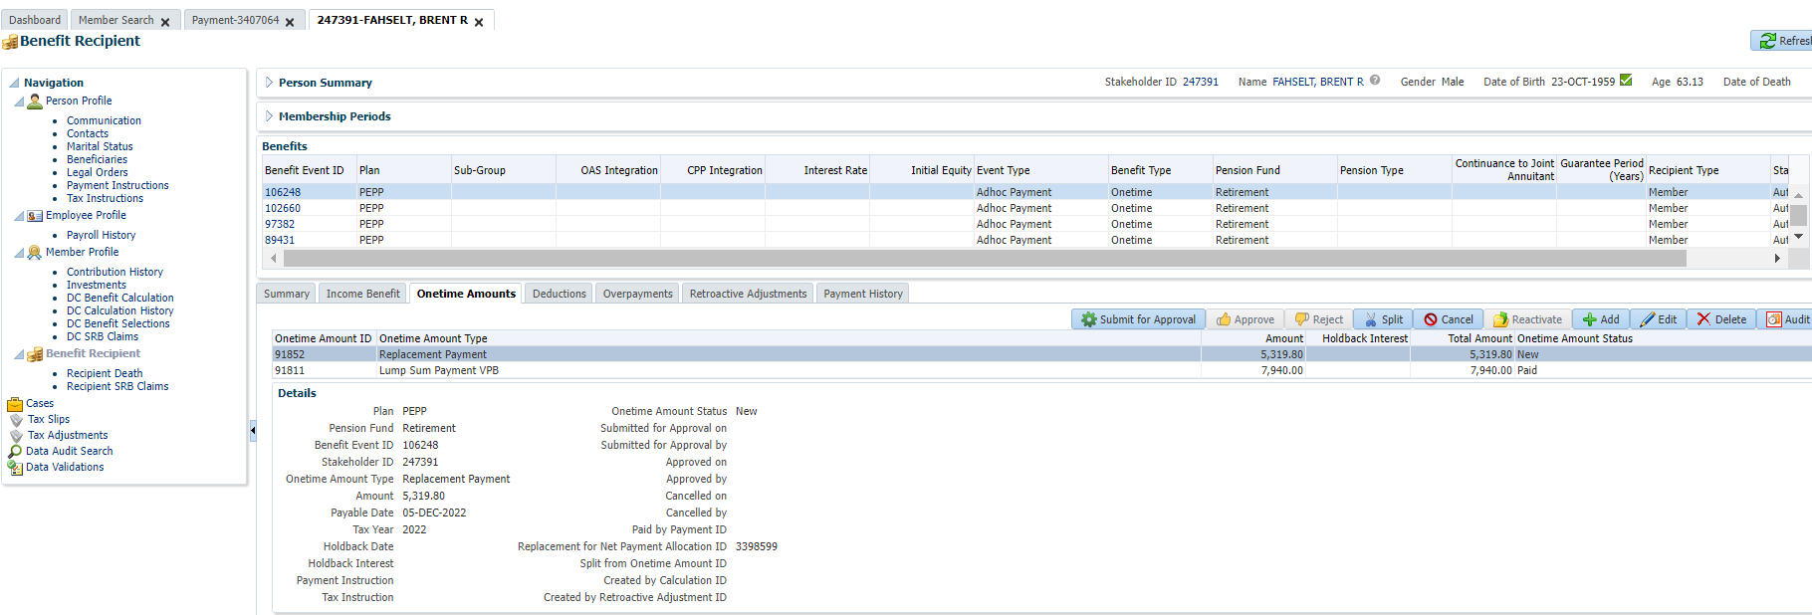

Highlight the replacement payment and click “edit” & add new payment instruction to update banking information:

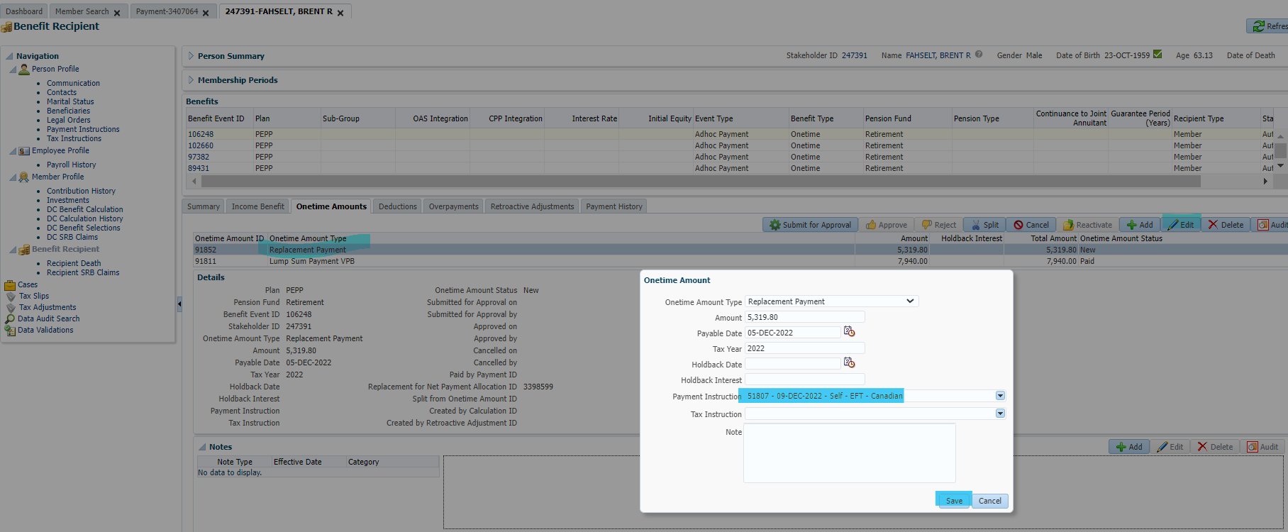

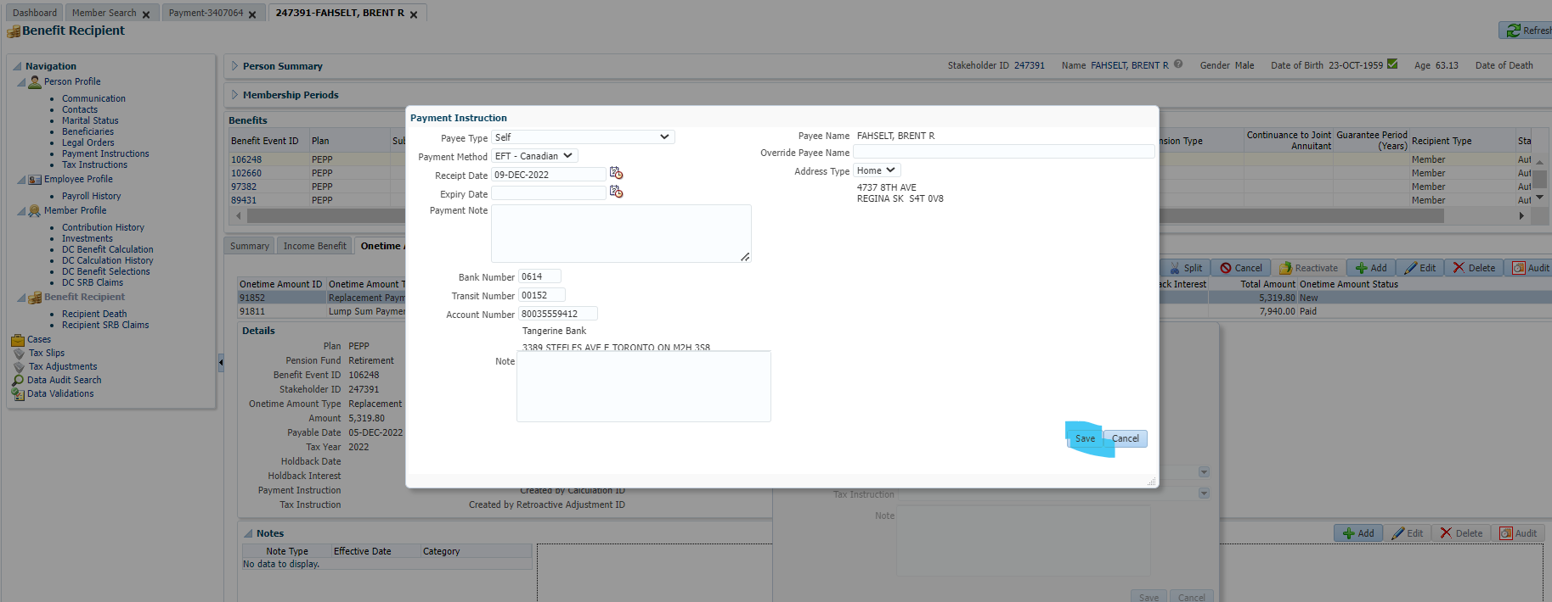

Leave the payable date & select the new payment instructions in this screen then press save:



Click submit for approval & approve:

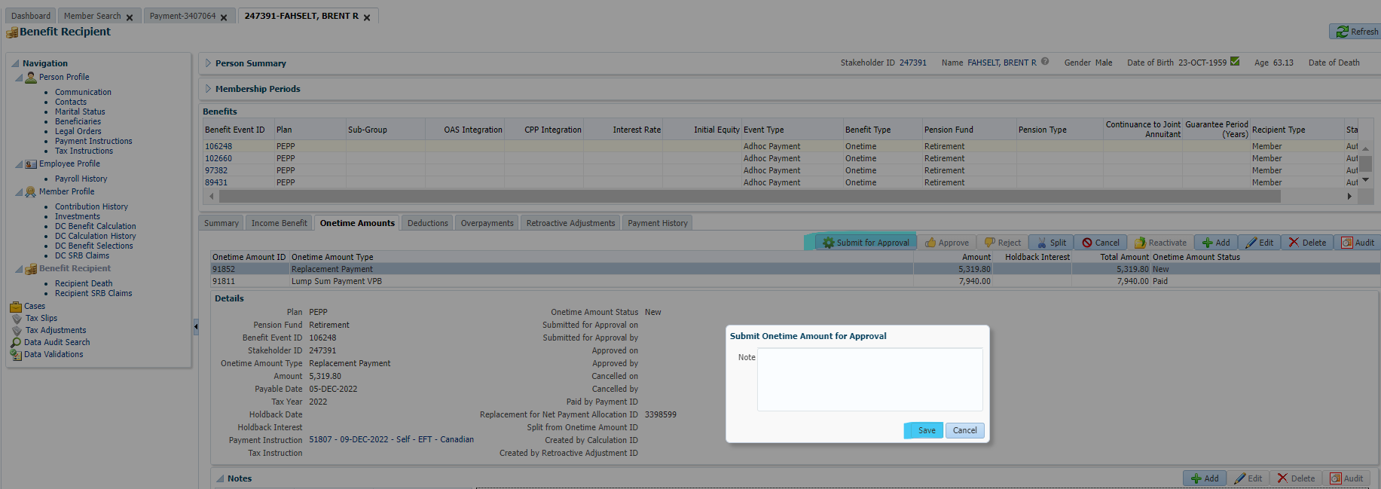

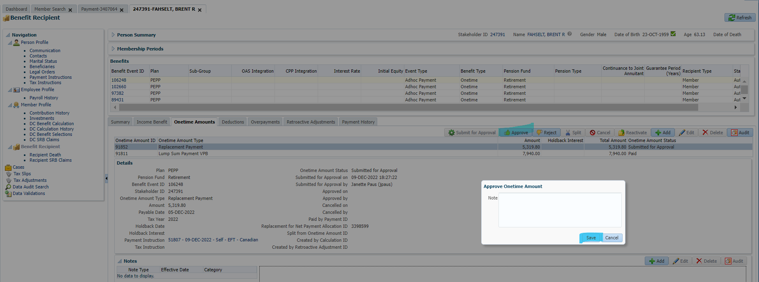

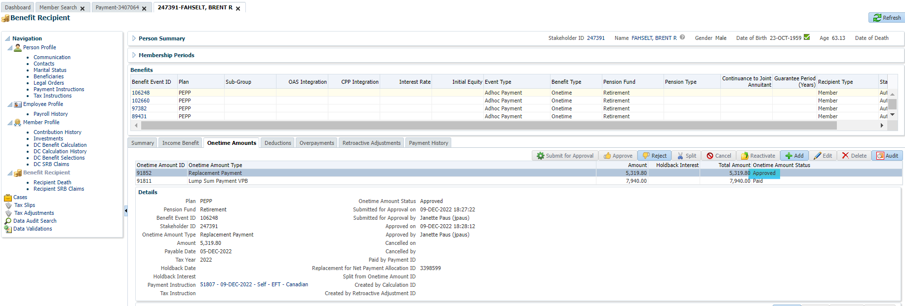

Wait for overnight PIT to generate new Paid by payment ID.

Next day – Sept 9 - Payment was correctly generated, no tax & correct amount.

**Scenario 2: PEPP member to PRIF & RRIF (two cheques)**

SID 314970

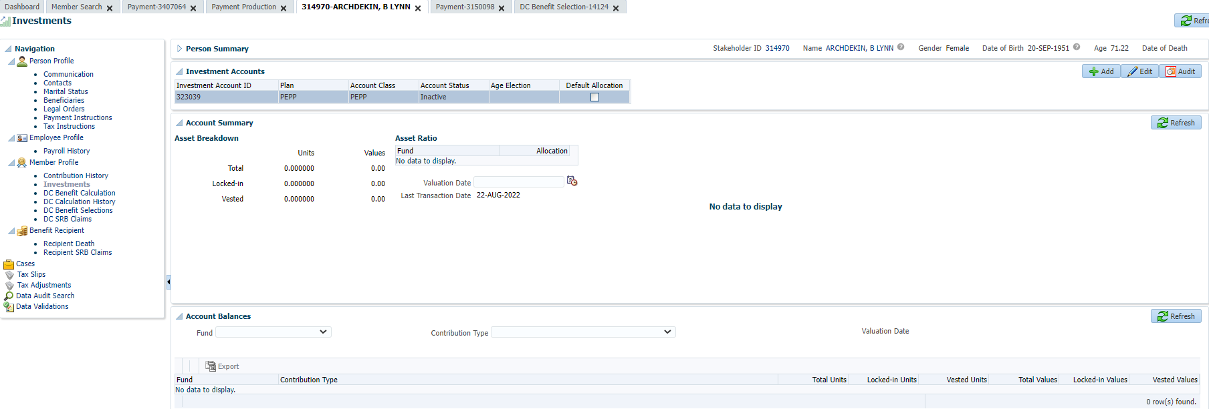

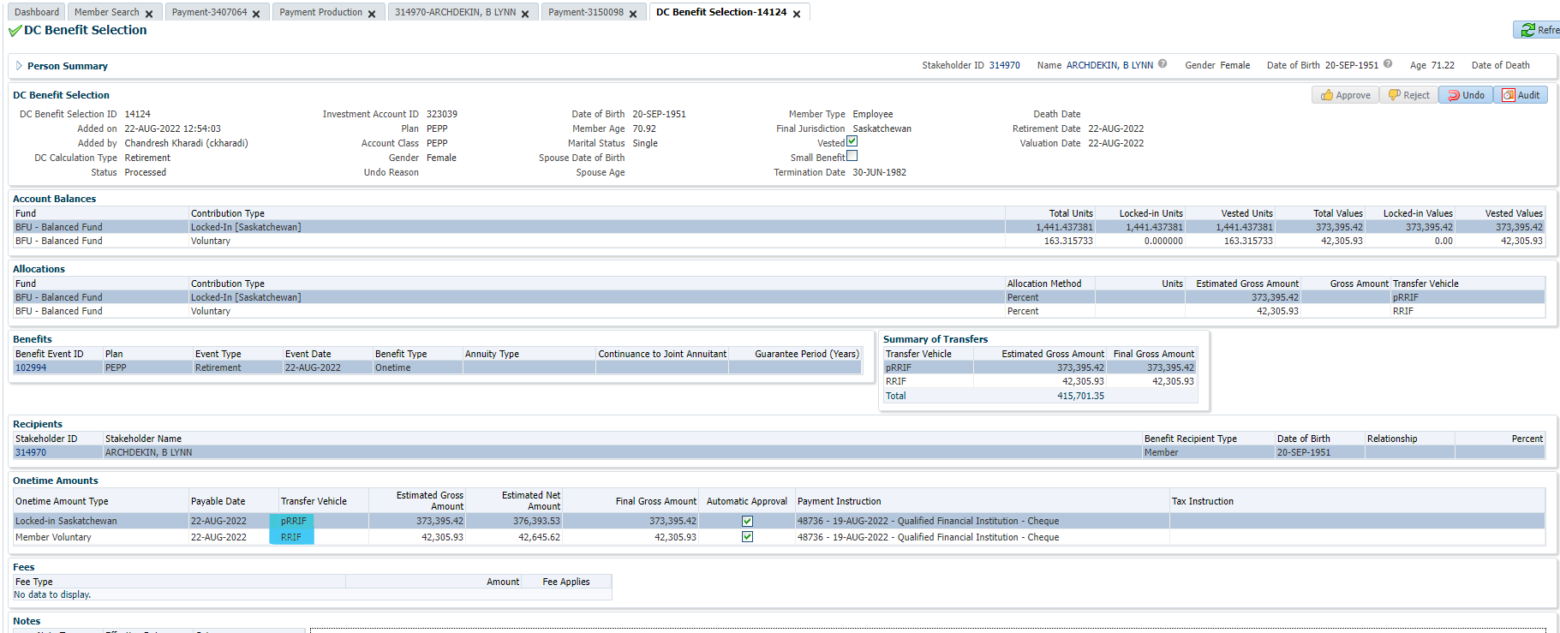

Go to benefit recipient and click on the one time amounts:

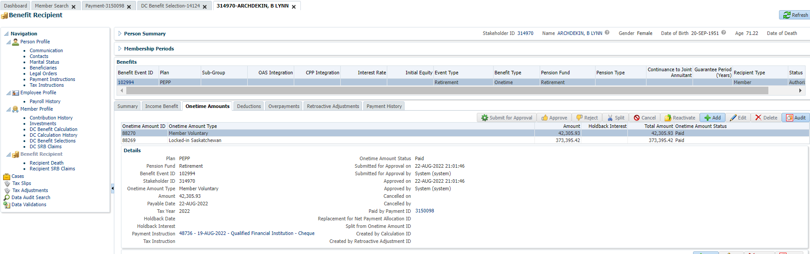

Original payment instruction details:

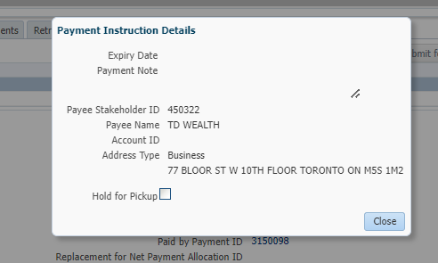

Click on paid by payment ID:

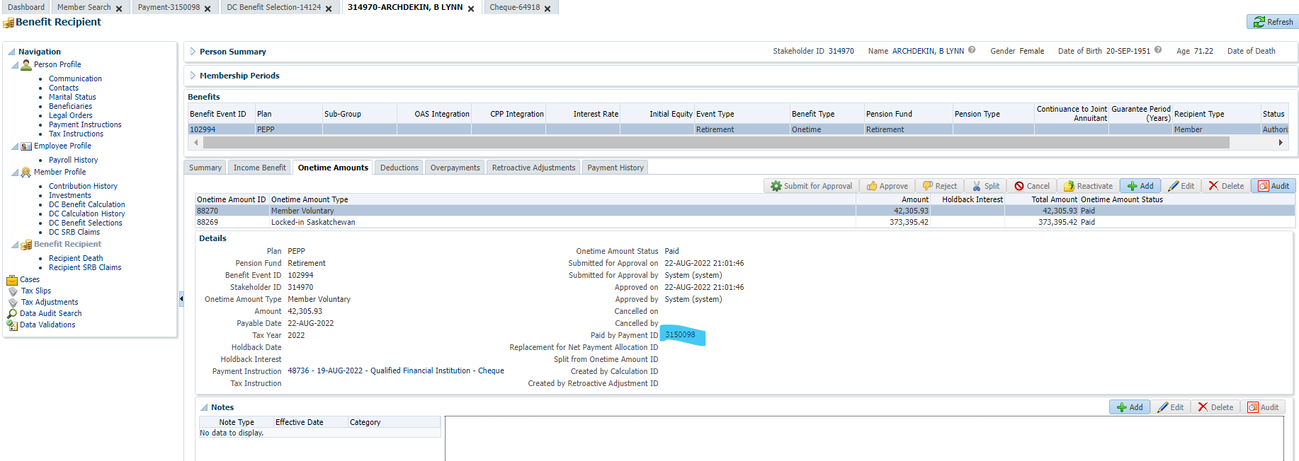

Click on the net pay allocation tab, and then click on the cheque ID number:

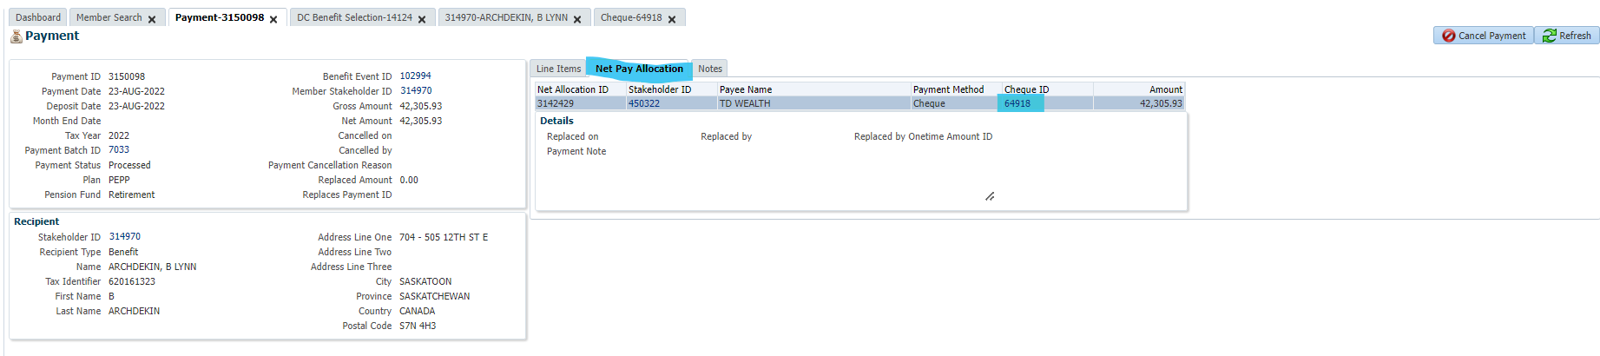

Then click on replace:

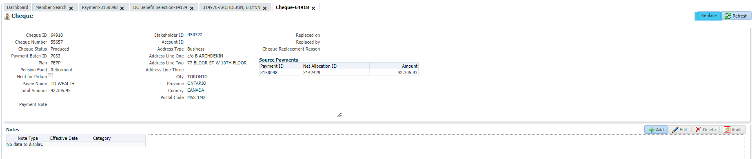

Select reason and then save:

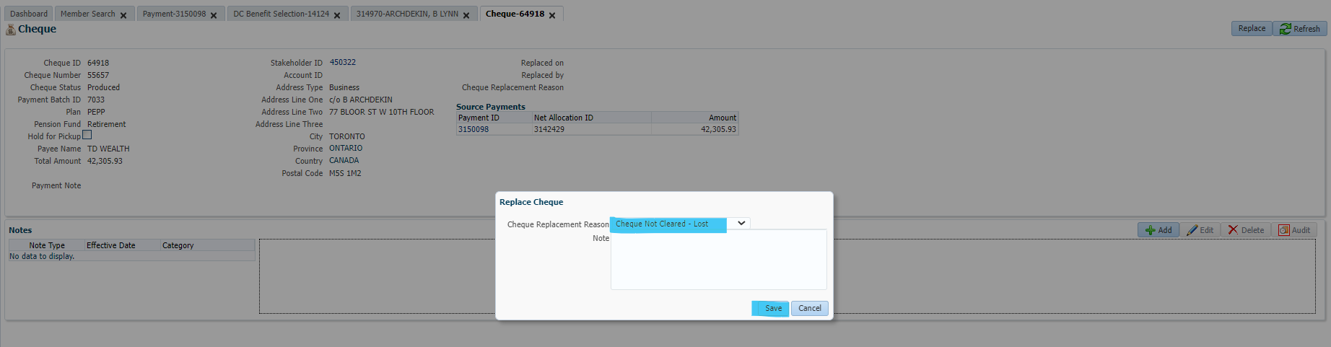

Follow the same steps for the other cheque.

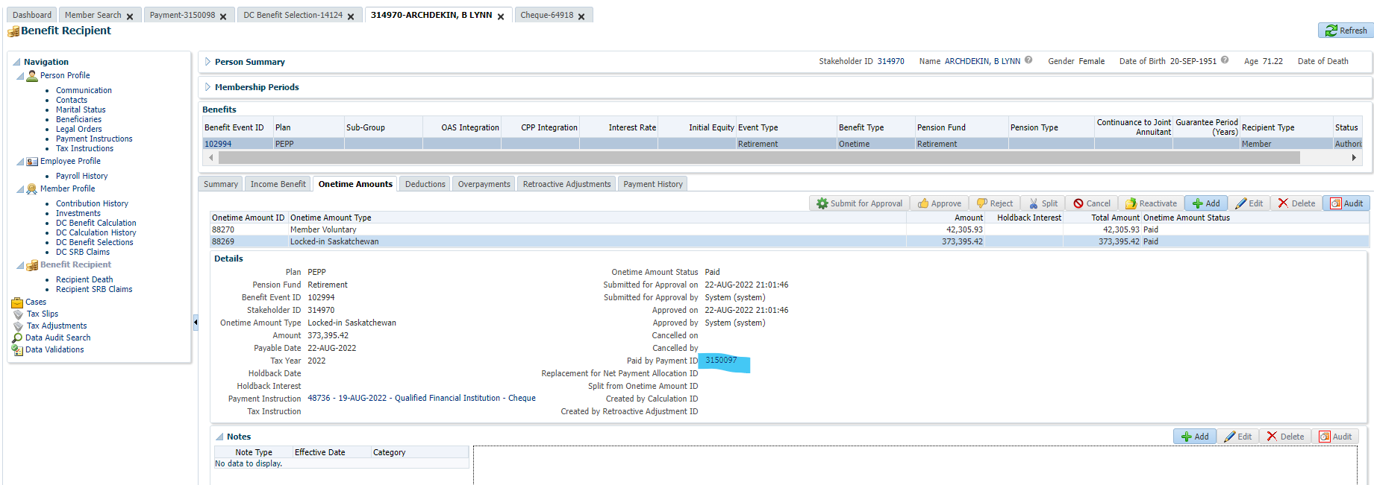

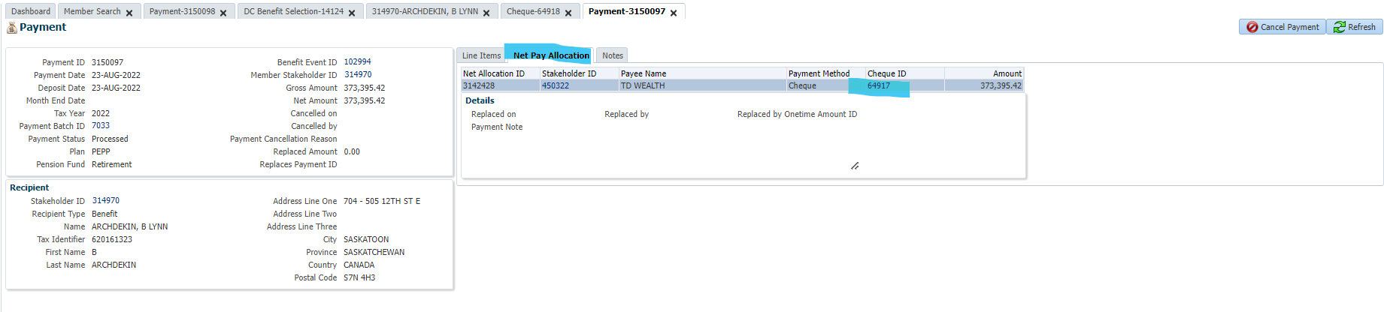

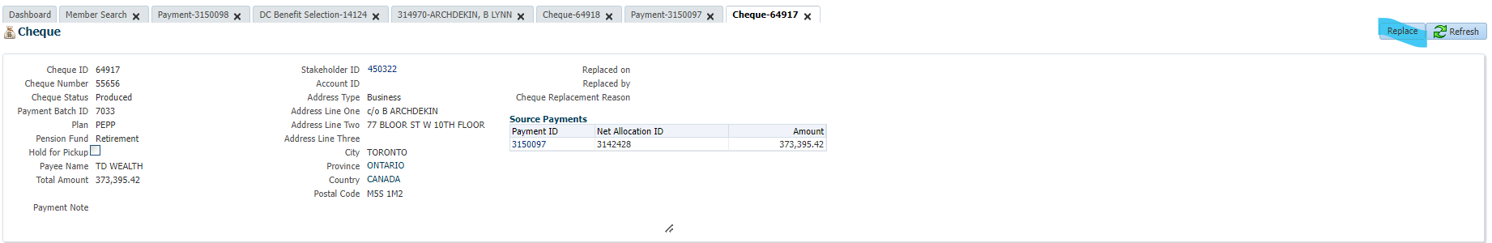

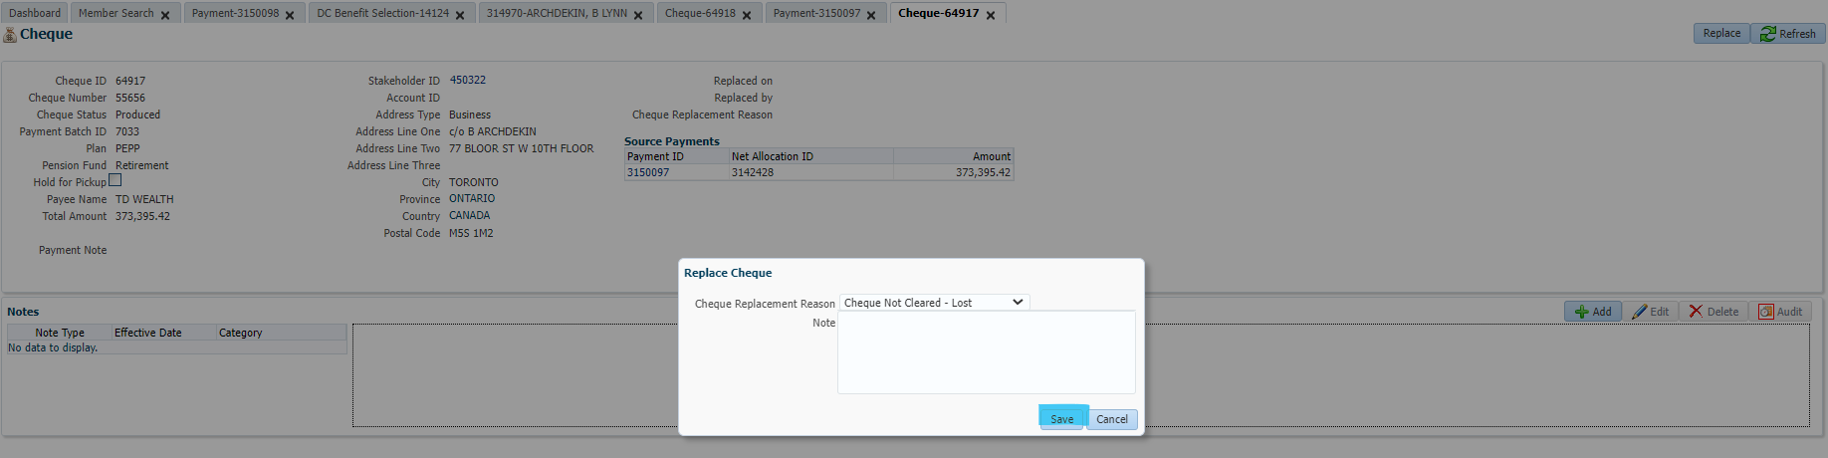

Benefit Recipient shows both replacement cheques as NEW:

Highlight each one & click Edit to update payment instructions:

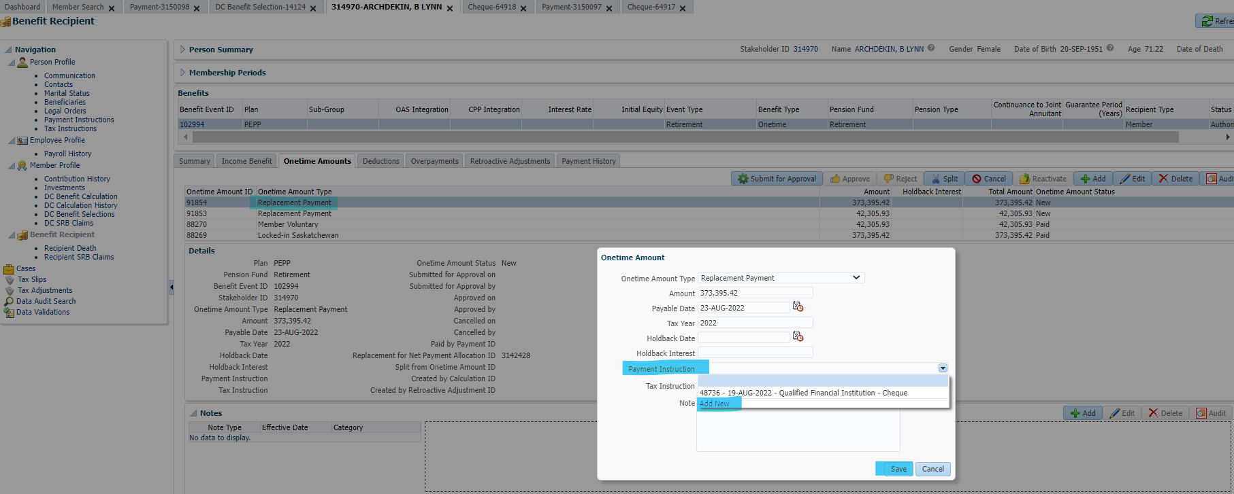

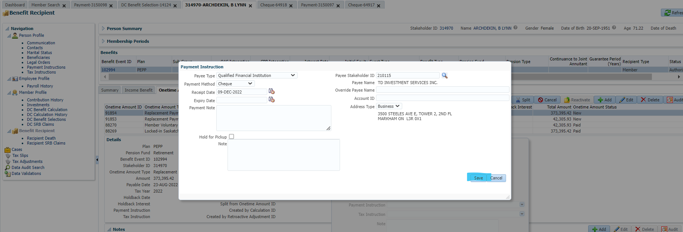

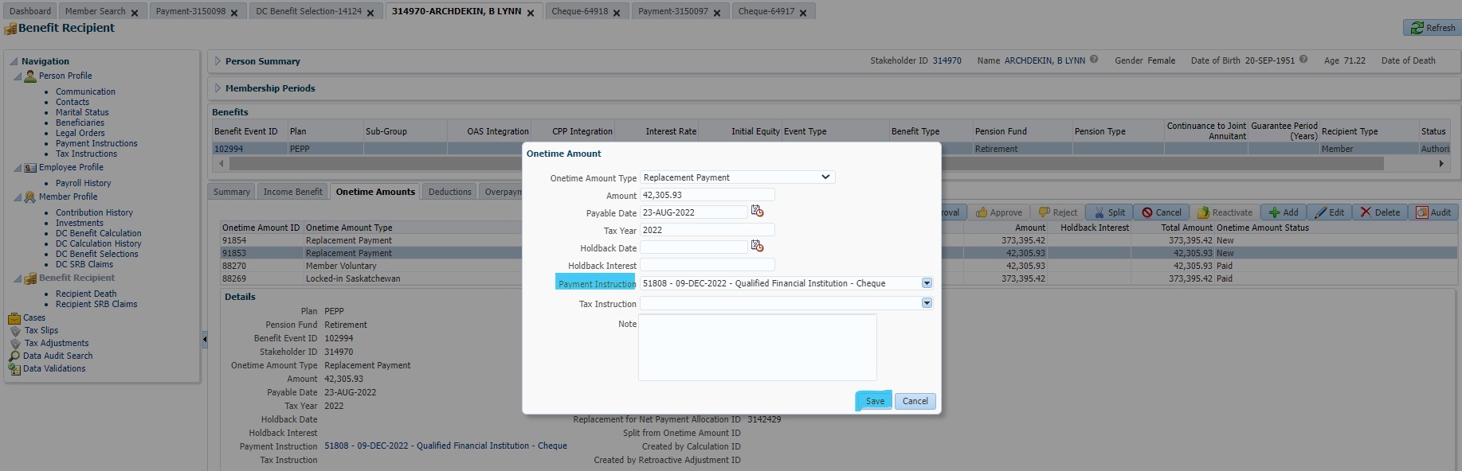

Approved both payments:

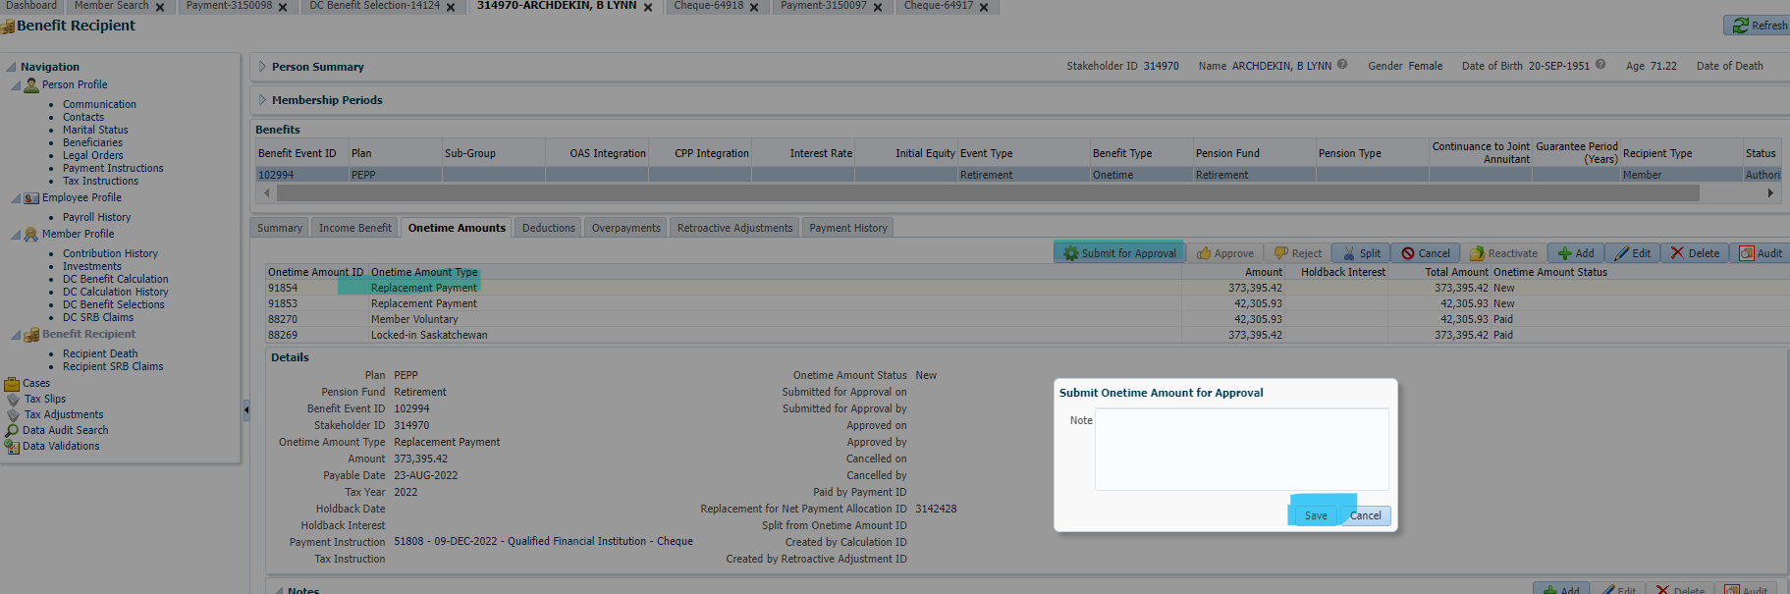

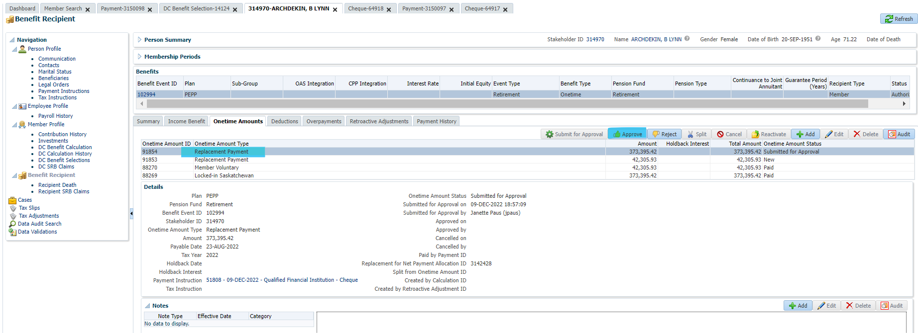

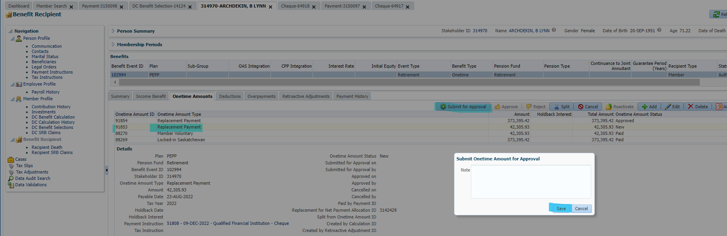

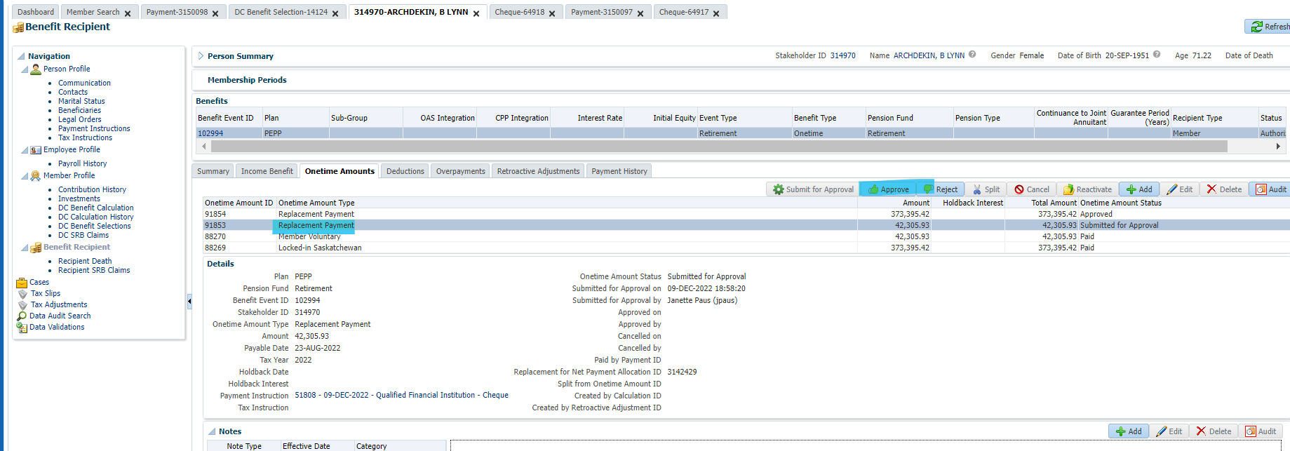

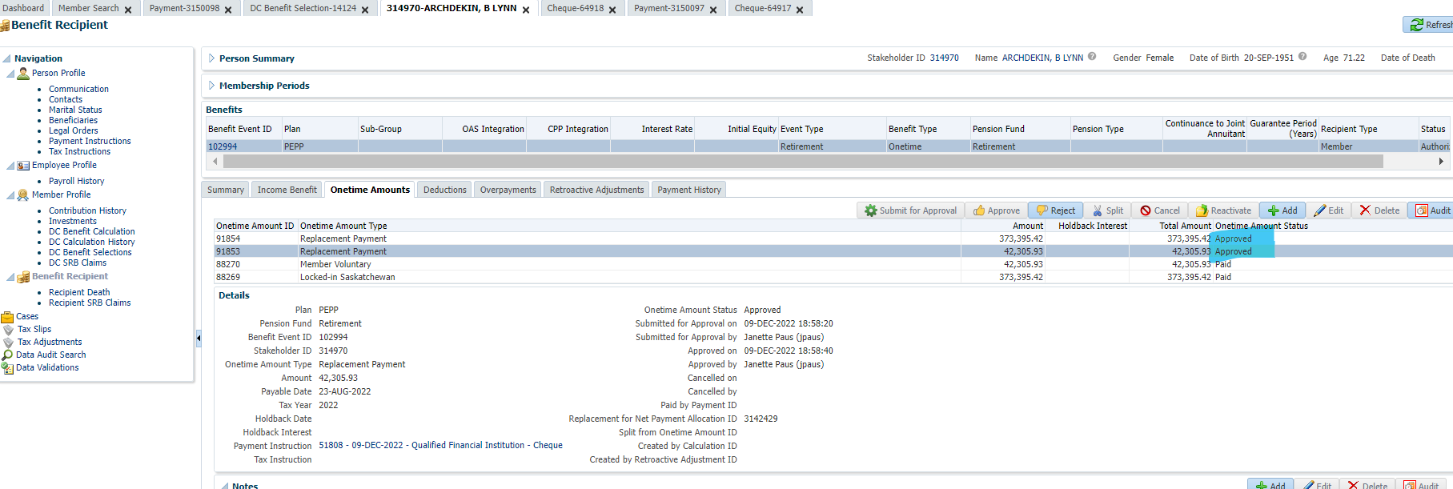

Waiting for PIT to run & new paid by payment id’s generated.

